**VLSM**

**Assume an IP Address: 192.168.0.0/20**

Host Bits: 12

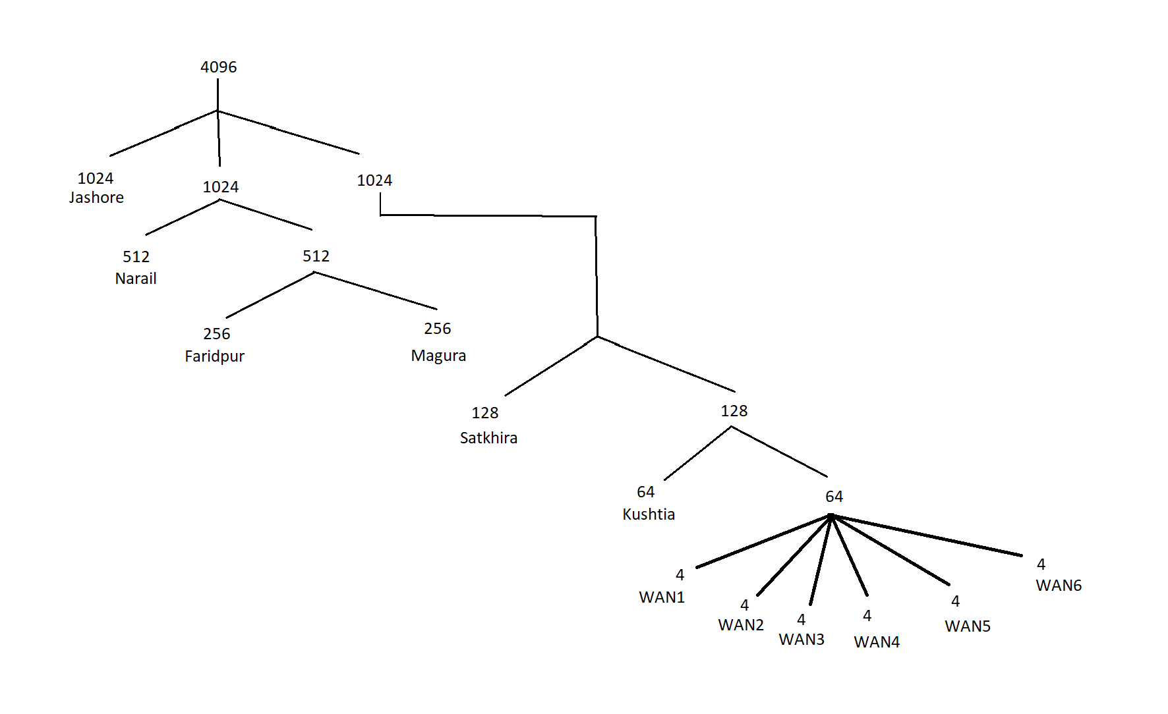

| **#** | **Host** | **IP** | **GIVE** | **Host Bits** | **Network**  **Bits** | **Range** | **Subnet MASK** |
| --- | --- | --- | --- | --- | --- | --- | --- |
| **Jashore** | **560** | **562** | **1024** | **10** | **22** | **192.168.0.0-**  **192.168.3.255** | **255.255.252.0** |
| **Narail** | **350** | **352** | **512** | **9** | **23** | **192.168.4.0-**  **192.168.5.255** | **255.255.254.0** |
| **Faridpur** | **210** | **212** | **256** | **8** | **24** | **192.168.6.0-**  **192.168.6.255** | **255.255.255.0** |
| **Magura** | **128** | **130** | **256** | **8** | **24** | **192.168.7.0-**  **192.168.7.255** | **255.255.255.0** |
| **Satkhira** | **80** | **82** | **128** | **7** | **25** | **192.168.8.0-**  **192.168.8.127** | **255.255.255.128** |
| **Kushtia** | **40** | **42** | **64** | **6** | **26** | **192.168.8.128-**  **192.168.8.191** | **255.255.255.192** |
| **WAN1** | **2** | **4** | **4** | **2** | **30** | **192.168.8.192-192.168.8.195** | **255.255.255.252** |
| **WAN2** | **2** | **4** | **4** | **2** | **30** | **192.168.8.196-192.168.8.199** | **255.255.255.252** |
| **WAN3** | **2** | **4** | **4** | **2** | **30** | **192.168.8.200-192.168.8.203** | **255.255.255.252** |
| **WAN4** | **2** | **4** | **4** | **2** | **30** | **192.168.8.204-192.168.8.207** | **255.255.255.252** |
| **WAN5** | **2** | **4** | **4** | **2** | **30** | **192.168.8.208-192.168.8.211** | **255.255.255.252** |
| **WAN6** | **2** | **4** | **4** | **2** | **30** | **192.168.8.212-192.168.8.215** | **255.255.255.252** |

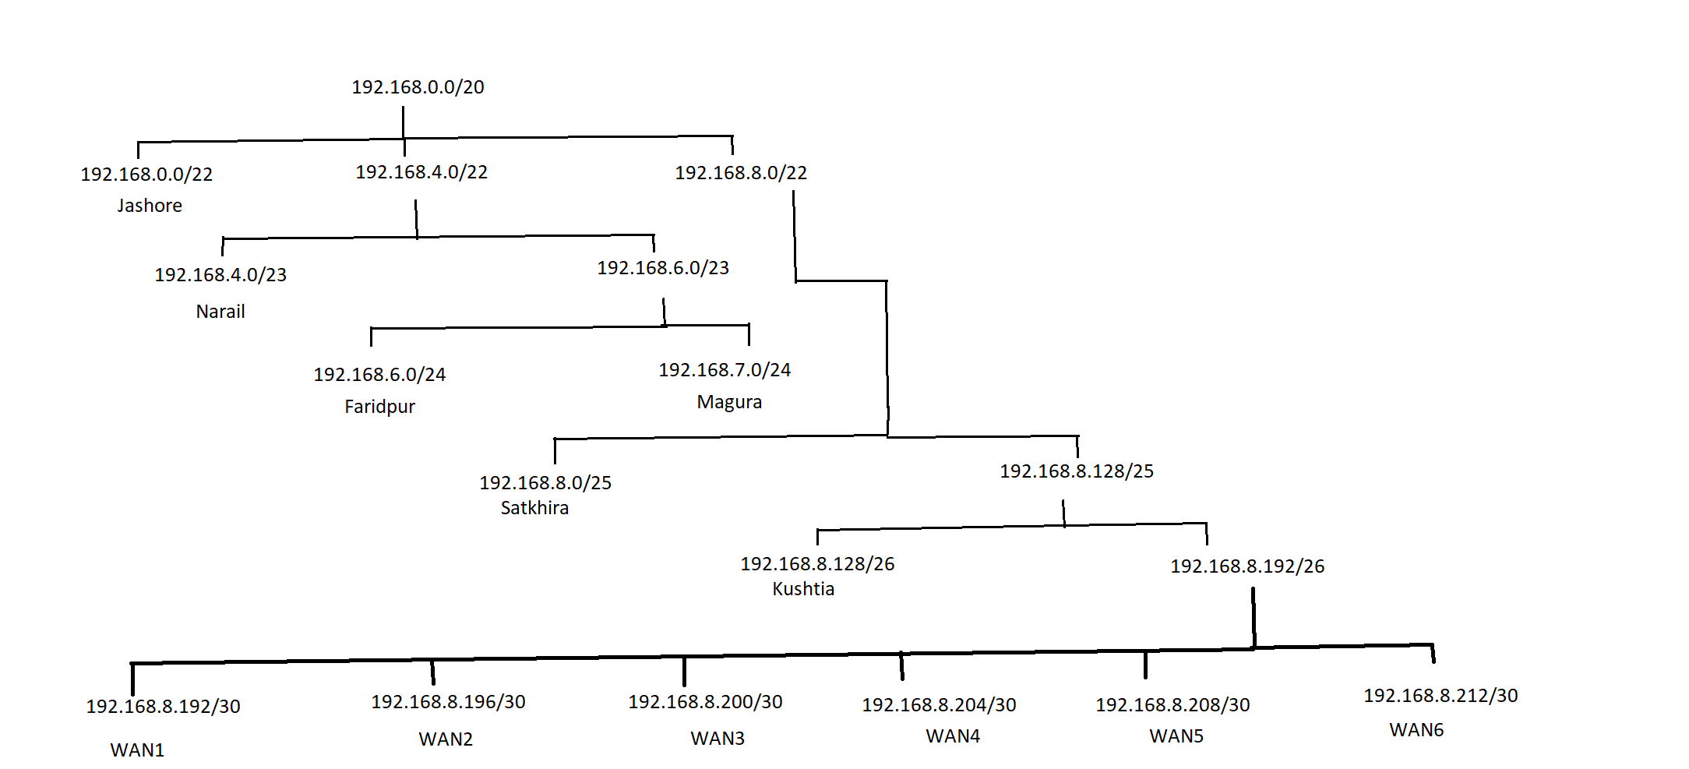

IP ADDRESS TABLE

| **DEVICE** | **INTERFACE** | **IPV4**  **ADDRESS** | **SUBNET**  **MASK** | **DEFAULT GATEWAY** |
| --- | --- | --- | --- | --- |
| **Magura Router** | **F0/0** | **192.168.7.1** | **255.255.255.0** | **N/A** |
|  | **Se3/0** | **192.168.8.201** | **255.255.255.252** | **N/A** |
|  | **Se2/0** | **192.168.8.193** | **255.255.255.252** | **N/A** |
|  | **Se6/0** | **192.168.8.197** | **255.255.255.252** | **N/A** |
| **Jashore Router** | **F0/0** | **192.168.0.1** | **255.255.252.0** | **N/A** |
|  | **Se3/0** | **192.168.8.206** | **255.255.255.252** | **N/A** |
|  | **Se2/0** | **192.168.8.198** | **255.255.255.252** | **N/A** |
| **Kushtia Router** | **F0/0** | **192.168.8.129** | **255.255.255.192** | **N/A** |
|  | **Se3/0** | **192.168.8.205** | **255.255.255.252** | **N/A** |
|  | **Se2/0** | **192.168.8.194** | **255.255.255.252** | **N/A** |
| **Satkhira Router** | **F0/0** | **192.168.8.1** | **255.255.255.128** | **N/A** |
|  | **Se2/0** | **192.168.8.202** | **255.255.255.252** | **N/A** |
|  | **Se6/0** | **192.168.8.213** | **255.255.255.252** | **N/A** |
|  | **Se3/0** | **192.168.8.209** | **255.255.255.252** | **N/A** |
| **Faridpur Router** | **F0/0** | **192.168.6.1** | **255.255.255.0** | **N/A** |
|  | **Se2/0** | **192.168.8.214** | **255.255.255.252** | **N/A** |
| **Narail Router** | **F0/0** | **192.168.4.1** | **255.255.254.0** | **N/A** |
|  | **Se2/0** | **192.168.8.210** | **255.255.255.252** | **N/A** |
| **PC Kushtia** | **NIC** | **192.168.8.132** | **255.255.255.0** | **192.168.8.129** |
| **PC Magura 1** | **NIC** | **192.168.7.2** | **255.255.255.0** | **192.168.7.1** |
| **PC Magura 2** | **NIC** | **192.168.7.3** | **255.255.255.0** | **192.168.7.1** |
| **PC Jashore** | **NIC** | **192.168.0.2** | **255.255.255.0** | **192.168.0.1** |
| **PC Satkhira** | **NIC** | **DHCP Assigned** | **DHCP Assigned** | **DHCP Assigned** |
| **PC Narail** | **NIC** | **DHCP Assigned** | **DHCP Assigned** | **DHCP Assigned** |
| **PC Faridpur 1** | **NIC** | **DHCP Assigned** | **DHCP Assigned** | **DHCP Assigned** |
| **PC Faridpur 2** | **NIC** | **DHCP Assigned** | **DHCP Assigned** | **DHCP Assigned** |
| **DNS Server** | **NIC** | **192.168.8.130** | **255.255.255.0** | **192.168.8.129** |
| **DHCP Server** | **NIC** | **192.168.8.131** | **255.255.255.0** | **192.168.8.129** |
| **Email Server** | **NIC** | **DHCP Assigned** | **DHCP Assigned** | **DHCP Assigned** |
| **Web Server** | **NIC** | **192.168.8.133** | **255.255.255.0** | **192.168.8.129** |

CONFIGURATION COMMANDS

**MAGURA ROUTER COMMANDS**

Router>en

Router#config t

Enter configuration commands, one per line. End with CNTL/Z.

Router(config)#int s2/0

Router(config-if)#ip address 192.168.8.193 255.255.255.252

Router(config-if)#no shut

%LINK-5-CHANGED: Interface Serial2/0, changed state to down

Router(config-if)#exit

Router(config)#int s6/0

Router(config-if)#ip address 192.168.8.197 255.255.255.252

Router(config-if)#no shut

%LINK-5-CHANGED: Interface Serial6/0, changed state to down

Router(config-if)#exit

Router(config)#int s3/0

Router(config-if)#ip address 192.168.8.201 255.255.255.252

Router(config-if)#no shut

%LINK-5-CHANGED: Interface Serial3/0, changed state to down

Router(config-if)#exit

Router(config)#

Router>en

Router#config t

Enter configuration commands, one per line. End with CNTL/Z.

Router(config)#int f0/0

Router(config-if)#ip address 192.168.7.1 255.255.255.0

Router(config-if)#no shut

Router(config-if)#

%LINK-5-CHANGED: Interface FastEthernet0/0, changed state to up

%LINEPROTO-5-UPDOWN: Line protocol on Interface FastEthernet0/0, changed state to up

**DEFAULT ROUTE TO JASHORE**

Router(config)#ip route 0.0.0.0 0.0.0.0 s6/0

Router(config)#exit

Router#

%SYS-5-CONFIG_I: Configured from console by console

Router#show ip route

Codes: C - connected, S - static, I - IGRP, R - RIP, M - mobile, B - BGP

D - EIGRP, EX - EIGRP external, O - OSPF, IA - OSPF inter area

N1 - OSPF NSSA external type 1, N2 - OSPF NSSA external type 2

E1 - OSPF external type 1, E2 - OSPF external type 2, E - EGP

i - IS-IS, L1 - IS-IS level-1, L2 - IS-IS level-2, ia - IS-IS inter area

* - candidate default, U - per-user static route, o - ODR

P - periodic downloaded static route

Gateway of last resort is 0.0.0.0 to network 0.0.0.0

C 192.168.7.0/24 is directly connected, FastEthernet0/0

192.168.8.0/24 is variably subnetted, 4 subnets, 2 masks

S 192.168.8.128/26 [1/0] via 192.168.8.194

C 192.168.8.192/30 is directly connected, Serial2/0

C 192.168.8.196/30 is directly connected, Serial6/0

C 192.168.8.200/30 is directly connected, Serial3/0

**S* 0.0.0.0/0 is directly connected, Serial6/0**

**[DEFAULT ROUTE IS VISIBLE IN ROUTING TABLE]**

Router#config t

Enter configuration commands, one per line. End with CNTL/Z.

Router(config)#ip route 0.0.0.0 0.0.0.0 s2/0 5

Router(config)#exit

Router#

%SYS-5-CONFIG_I: Configured from console by console

Router#show run

**ip route 0.0.0.0 0.0.0.0 Serial6/0**

**ip route 0.0.0.0 0.0.0.0 Serial2/0 5**

**SHUT DOWN PRIMARY ROUTE**

Router#config t

Enter configuration commands, one per line. End with CNTL/Z.

Router(config)#int s6/0

Router(config-if)#shut

Router(config-if)#

%LINK-5-CHANGED: Interface Serial6/0, changed state to administratively down

%LINEPROTO-5-UPDOWN: Line protocol on Interface Serial6/0, changed state to down

**STATIC ROUTING**

Router>en

Router#config t

Enter configuration commands, one per line. End with CNTL/Z.

Router(config)#ip route 192.168.8.128 255.255.255.192 192.168.8.194

Router(config)#ip route 192.168.0.0 255.255.252.0 192.168.8.194

Router(config)#ip route 192.168.8.0 255.255.255.128 192.168.8.202

Router(config)#ip route 192.168.4.0 255.255.254.0 192.168.8.202

Router(config)#ip route 192.168.6.0 255.255.255.0 192.168.8.202

Router(config)#

**RIP**

Router>en

Router#config t

Enter configuration commands, one per line. End with CNTL/Z.

Router(config)#router rip

Router(config-router)#version 2

Router(config-router)#redistribute static

Router(config-router)#end

Router#

**KUSHTIA ROUTER COMMANDS**

Router>en

Router#config t

Enter configuration commands, one per line. End with CNTL/Z.

Router(config)#int s2/0

Router(config-if)#ip address 192.168.8.194 255.255.255.252

Router(config-if)#no shut

Router(config-if)#

%LINK-5-CHANGED: Interface Serial2/0, changed state to up

%LINEPROTO-5-UPDOWN: Line protocol on Interface Serial2/0, changed state to up

Router#config t

Enter configuration commands, one per line. End with CNTL/Z.

Router(config)#int s3/0

Router(config-if)#ip address 192.168.8.205 255.255.255.252

Router(config-if)#no shut

%LINK-5-CHANGED: Interface Serial3/0, changed state to down

Router(config-if)#

%LINK-5-CHANGED: Interface Serial3/0, changed state to up

%LINEPROTO-5-UPDOWN: Line protocol on Interface Serial3/0, changed state to up

Router#config t

Enter configuration commands, one per line. End with CNTL/Z.

Router(config)#int f0/0

Router(config-if)#ip address 192.168.8.129 255.255.255.192

Router(config-if)#no shut

**STATIC ROUTING**

Router>en

Router#config t

Enter configuration commands, one per line. End with CNTL/Z.

Router(config)#ip route 192.168.0.0 255.255.252.0 192.168.8.206

Router(config)#ip route 192.168.7.0 255.255.255.0 192.168.8.193

Router(config)#ip route 192.168.8.0 255.255.255.128 192.168.8.193

Router(config)#ip route 192.168.4.0 255.255.254.0 192.168.8.193

Router(config)#ip route 192.168.6.0 255.255.255.0 192.168.8.193

Router(config)#

Router(config-if)#

%LINK-5-CHANGED: Interface FastEthernet0/0, changed state to up

%LINEPROTO-5-UPDOWN: Line protocol on Interface FastEthernet0/0, changed state to up

**JASHORE ROUTER COMMANDS**

Router>en

Router#config t

Enter configuration commands, one per line. End with CNTL/Z.

Router(config)#int s2/0

Router(config-if)#ip address 192.168.8.198 255.255.255.252

Router(config-if)#no shut

Router(config-if)#

%LINK-5-CHANGED: Interface Serial2/0, changed state to up

Router(config-if)#int s3/0

Router(config-if)#ip address 192.168.8.206 255.255.255.252

Router(config-if)#no shut

Router(config-if)#

%LINK-5-CHANGED: Interface Serial3/0, changed state to up

%LINEPROTO-5-UPDOWN: Line protocol on Interface Serial3/0, changed state to up

Router>en

Router#config t

Enter configuration commands, one per line. End with CNTL/Z.

Router(config)#int f0/0

Router(config-if)#ip address 192.168.0.1 255.255.252.0

Router(config-if)#no shut

Router(config-if)#

%LINK-5-CHANGED: Interface FastEthernet0/0, changed state to up

%LINEPROTO-5-UPDOWN: Line protocol on Interface FastEthernet0/0, changed state to up

**STATIC ROUTING**

Router>en

Router#config t

Router(config)#ip route 192.168.8.128 255.255.255.192 192.168.8.205

Router(config)#ip route 192.168.7.0 255.255.255.0 192.168.8.205

Router(config)#ip route 192.168.8.0 255.255.255.128 192.168.8.205

Router(config)#ip route 192.168.4.0 255.255.254.0 192.168.8.205

Router(config)#ip route 192.168.6.0 255.255.255.0 192.168.8.205

Router(config)#

**SATKHIRA ROUTER COMMANDS**

Router>en

Router#config t

Enter configuration commands, one per line. End with CNTL/Z.

Router(config)#int s2/0

Router(config-if)#ip address 192.168.8.202 255.255.255.252

Router(config-if)#no shut

Router(config-if)#

%LINK-5-CHANGED: Interface Serial2/0, changed state to up

Router(config-if)#exit

Router(config)#int s3/0

Router(config-if)#ip address 192.168.8.209 255.255.255.252

Router(config-if)#no shut

%LINK-5-CHANGED: Interface Serial3/0, changed state to down

Router(config-if)#

Router(config-if)#exit

Router(config)#int s6/0

Router(config-if)#ip address 192.168.8.213 255.255.255.252

Router(config-if)#no shut

%LINK-5-CHANGED: Interface Serial6/0, changed state to down

Router(config-if)#

Router>en

Router#config t

Enter configuration commands, one per line. End with CNTL/Z.

Router(config)#int f0/0

Router(config-if)#ip address 192.168.8.1 255.255.255.128

Router(config-if)#no shut

Router(config-if)#

%LINK-5-CHANGED: Interface FastEthernet0/0, changed state to up

%LINEPROTO-5-UPDOWN: Line protocol on Interface FastEthernet0/0, changed state to up

**DHCP**

Router>en

Router#config t

Enter configuration commands, one per line. End with CNTL/Z.

Router(config)#int f0/0

Router(config-if)#ip helper-address 192.168.8.131

Router(config-if)#exit

**RIP**

Router(config)#router rip

Router(config-router)#version 2

Router(config-router)#no auto-summary

Router(config-router)#network 192.168.8.200

Router(config-router)#network 192.168.8.208

Router(config-router)#network 192.168.8.212

Router(config-router)#network 192.168.8.0

Router(config-router)#passive-interface f0/0

Router(config-router)#end

Router#

%SYS-5-CONFIG_I: Configured from console by console

Router#copy run start

Destination filename [startup-config]?

Building configuration...

[OK]

Router#

Router#

**NARAIL ROUTER COMMANDS**

Router>en

Router#config t

Enter configuration commands, one per line. End with CNTL/Z.

Router(config)#int s2/0

Router(config-if)#ip address 192.168.8.210 255.255.255.252

Router(config-if)#no shut

Router(config-if)#

%LINK-5-CHANGED: Interface Serial2/0, changed state to up

Router>en

Router#config t

Enter configuration commands, one per line. End with CNTL/Z.

Router(config)#int f0/0

Router(config-if)#ip address 192.168.4.1 255.255.254.0

Router(config-if)#no shut

Router(config-if)#

%LINK-5-CHANGED: Interface FastEthernet0/0, changed state to up

%LINEPROTO-5-UPDOWN: Line protocol on Interface FastEthernet0/0, changed state to up

**DHCP**

Router>en

Router#config t

Enter configuration commands, one per line. End with CNTL/Z.

Router(config)#int f0/0

Router(config-if)#ip helper-address 192.168.8.131

Router(config-if)#exit

Router(config)#

**RIP**

Router>en

Router#config t

Enter configuration commands, one per line. End with CNTL/Z.

Router(config)#router rip

Router(config-router)#version 2

Router(config-router)#no auto-summary

Router(config-router)#network 192.168.8.208

Router(config-router)#network 192.168.4.0

Router(config-router)#passive-interface f0/0

Router(config-router)#end

Router#

%SYS-5-CONFIG_I: Configured from console by console

Router#copy run start

Destination filename [startup-config]?

Building configuration...

[OK]

Router#

Router#

**FARIDPUR ROUTER COMMANDS**

Router>en

Router#config t

Enter configuration commands, one per line. End with CNTL/Z.

Router(config)#int s2/0

Router(config-if)#ip address 192.168.8.214 255.255.255.252

Router(config-if)#no shut

Router(config-if)#

%LINK-5-CHANGED: Interface Serial2/0, changed state to up

Router>en

Router#config t

Enter configuration commands, one per line. End with CNTL/Z.

Router(config)#int f0/0

Router(config-if)#ip address 192.168.6.1 255.255.255.0

Router(config-if)#no shut

Router(config-if)#

%LINK-5-CHANGED: Interface FastEthernet0/0, changed state to up

%LINEPROTO-5-UPDOWN: Line protocol on Interface FastEthernet0/0, changed state to up

**DHCP**

Router>en

Router#config t

Enter configuration commands, one per line. End with CNTL/Z.

Router(config)#int f0/0

Router(config-if)#ip helper-address 192.168.8.131

Router(config-if)#exit

Router(config)#

**RIP**

Router>en

Router#config t

Enter configuration commands, one per line. End with CNTL/Z.

Router(config)#router rip

Router(config-router)#version 2

Router(config-router)#no auto-summary

Router(config-router)#network 192.168.8.212

Router(config-router)#network 192.168.6.0

Router(config-router)#passive-interface f0/0

Router(config-router)#end

Router#

%SYS-5-CONFIG_I: Configured from console by console

Router#copy run start

Destination filename [startup-config]?

Building configuration...

[OK]

Router#